NAME: KESLEY JEREMY GWADA

WEEK 2 ASSIGNMENT 1

SETTING UP YOUR DEV ENVIRONMENT

1. Already installed windows 11 OS on my machine

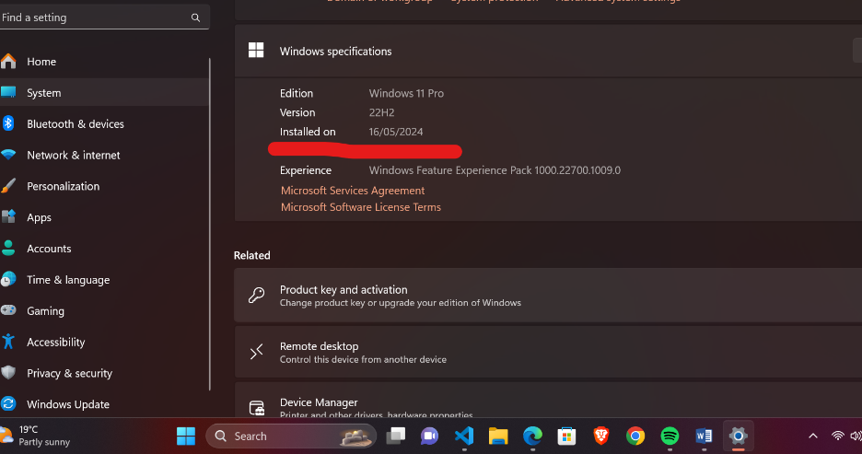

1. To download and install Visual Studio Code, first open your web browser and visit the official website at [https://code.visualstudio.com/](https://code.visualstudio.com/). Click the "Download for Windows" button. Once the download is complete, locate the installer file in your "Downloads" folder and double-click it to run the installer. Follow the on-screen instructions: accept the license agreement, choose the installation location, and select additional tasks such as adding to the PATH and creating a desktop icon. Finally, click "Install" to complete the process, and you can choose to launch Visual Studio Code immediately after installation.

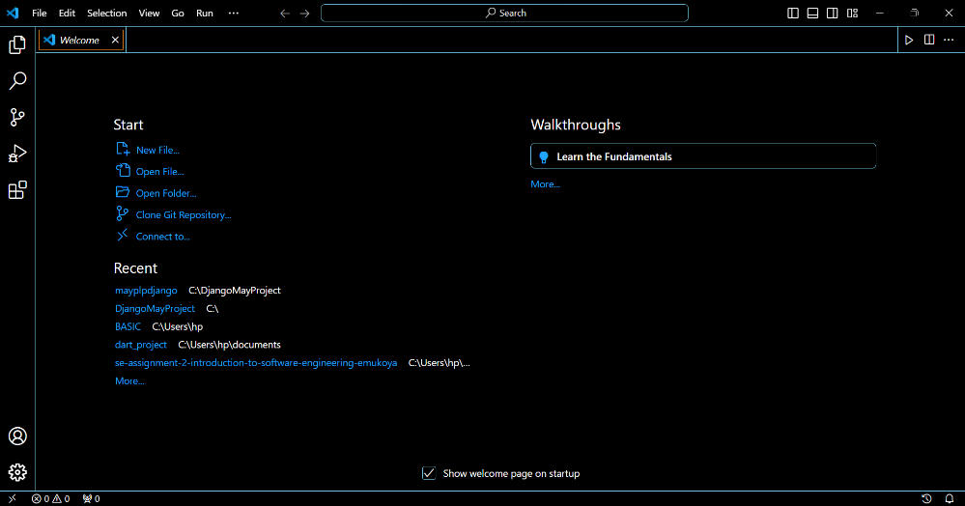

1. To set up a version control system, begin by installing Git on your local machine. Download the installer from [https://git-scm.com/](https://git-scm.com/), run it, and follow the setup instructions. After installation, open your terminal and configure Git with your user information by running `git config --global user.name “jeremykj04”and `git config --global user.email "gwadakj@gmail.com"`.

Next, create a GitHub account at [https://github.com](https://github.com) to host your repositories. Once registered, create a new repository on GitHub for your project. Back on your local machine, navigate to your project directory in the terminal and initialize a Git repository by running `git init`. Add your project files to the staging area using `git add .` and make your first commit with `git commit -m "Initial commit"`. Finally, link your local repository to the remote GitHub repository with `git remote add origin https://github.com/jeremykj04/your-repository.git` and push your changes using `git push -u origin master`. This sets up version control, allowing you to track changes and collaborate on your project through Git and GitHub.

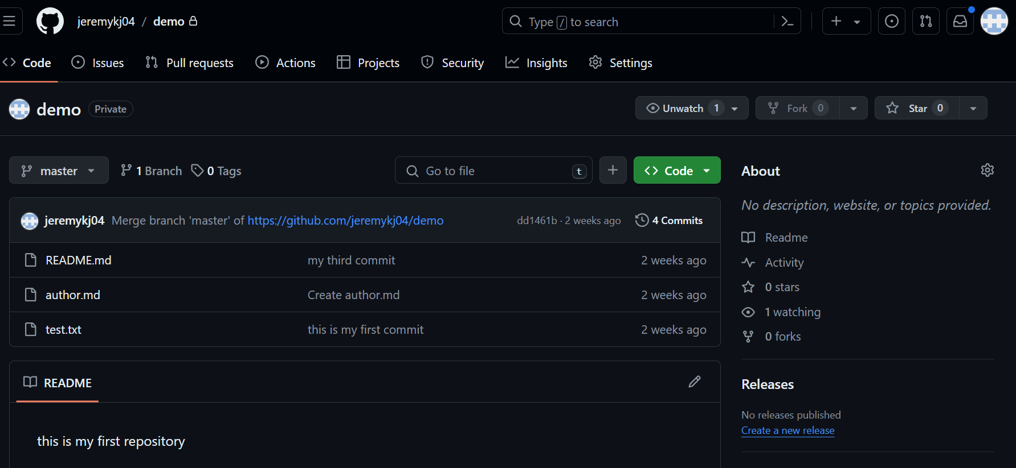

1. To install the necessary programming languages and runtimes for your project on Windows, start by downloading Python from the official website [http://www.python.org] (http://www.python.org). Click the "Download" button for the latest version and run the downloaded installer. During installation, ensure you check the box that says "Add Python to PATH" before clicking "Install Now" to make Python and its package manager `pip` accessible from the command line. After installation, open GitBash and verify the installation by typing `python --version` and `pip --version`, ensuring you see the version numbers for both Python and pip, confirming successful installation.

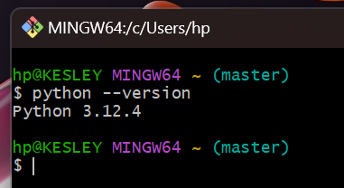

1. To configure a MySQL database on Windows, download the MySQL Installer from [https://dev.mysql.com/downloads/windows/installer/5.7.html](https://dev.mysql.com/downloads/windows/installer/5.7.html), ensuring to select the appropriate version for your system (typically 64-bit). Once downloaded, run the installer by double-clicking the downloaded file. Follow the installation wizard steps, choosing the "Developer Default" setup type, which includes MySQL Server, MySQL Workbench, connectors, and other tools needed for development. During installation, you may be prompted to set a root password for MySQL; choose a strong password and keep it secure. After installation completes, MySQL Server will be configured and ready to use on your Windows machine, accessible via MySQL Workbench or command-line tools like MySQL Shell.

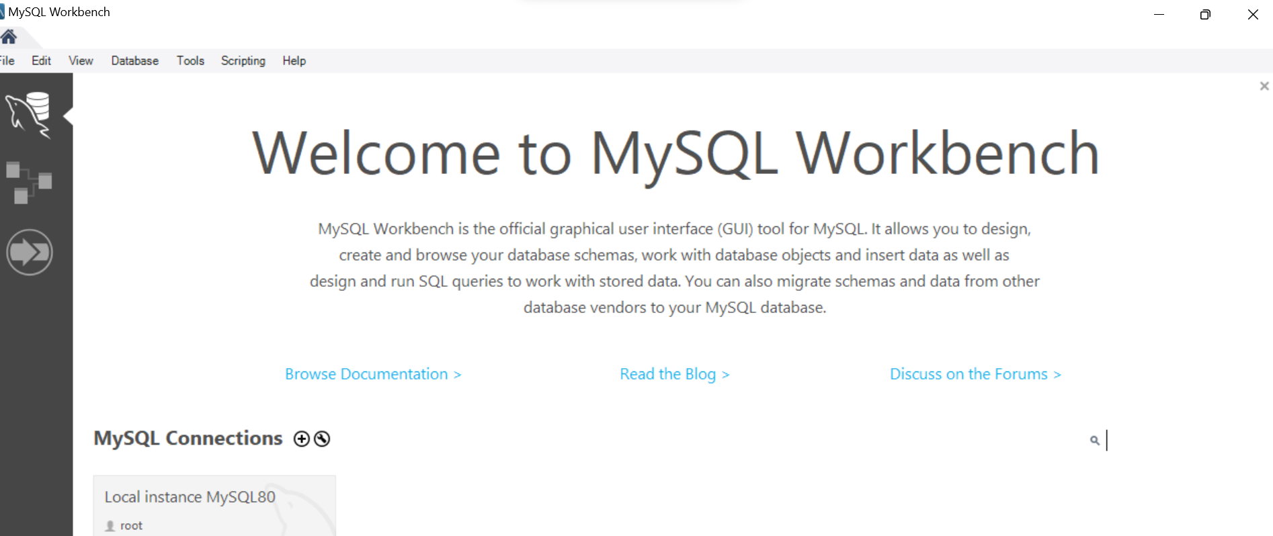

1. GITHUB REPOSITORY LINK

https://github.com/jeremykj04/Ecommerce_with_Django